|  |  |
| --- | --- |
| **VMP** | VMP / QA / R / 05 |
| REV.NO :1.0 |
| Page 1 |
| Date: 31.01.2020 |

# 

# Campaign Batch Schedule – Final Checklist

**Document Version Information**

|  |  |  |  |
| --- | --- | --- | --- |
| Project Name | INTEL | Doc Version No |  |
| Document Title | satg_APJ_satgdepoee_EN_2024_APJ_Workshop_31424_C-MKA-40733_T-MKA-41087_Reminder | Preparation Date | 20-3-2024 |
| Prepared/Updated By | Prakash Kumar M | Review Date | 20-3-2024 |
| Reviewed By | Swati |  |  |

**Revision History**

|  |  |  |  |  |
| --- | --- | --- | --- | --- |
| S.no | Description | Update By & Date | Approval By | Comments |
|  |  |  |  |  |
|  |  |  |  |  |
|  |  |  |  |  |

|  |  |
| --- | --- |
| Client Name | INTEL |
| Campaign /Eloqua Brochure Name | satg_APJ_satgdepoee_EN_2024_APJ_Workshop_31424_C-MKA-40733_T-MKA-41087_Reminder |
| Is it a Nurture Campaign? | NA |
| If yes, please update the Nurture Campaign Ending Date (Always-on or End date to be specified) | NA |
| Respective Notification mails are enabled and checked for Nurture Campaigns? | NA |
| If APJ CMX nurture, ensure this nurture is excluded in AEN nurture i.e., update the shared filter - AEN Nurture_MKA-24838 | NA |
| If APJ CMX nurture, have we checked with CSM if the nurture comes under prioritization and necessary setup is done. | NA |
| If PRC Campaign, Ensure the below shared lists are excluded,  Intel PRC_xinjie partner list_Exclusion List  PRC Exclusive Sales Focus Group  Intel PRC - QQ Customer list to exclude | NA |
| Is Email throttle step added before each email send step? | NA (Transactional Email) |
| If Throttle step is added, check if there is NO infinite loop added | NA |
| If the campaign is time sensitive, please check if the evaluation period is set correctly? | NA |
| If the campaign is time insensitive, please check the evaluation period is set as per Marketer’s approval? | NA |
| Have we added the campaign specific exit Shared list No Path? | Yes |
| If Email throttle step is not added, ensure that we have the proper approval from Marketer & Global team? | NA |
| For JP campaigns, have we excluded the Shared Filter “JP Blacklisted Contacts” in Segment/Campaign flow.  Note: Applicable for both marketing & transaction emails including confirmation email | NA |
| Verify no blank campaign template is created and used (it should be automated campaign from JIRA) | used Jira created campaign |
| Verify Campaign specific Entry and Exit shared list for reporting purposes | Yes |
| Have we updated the Campaign ID? | Yes |
| Verify the Parent (Main), Child (Sub – If required) campaigns are created & activated?  If activated specify the campaign name. | NA |
| Are we sending emails during weekends? | NO |
| Are we sending emails between 8am to 6pm time duration? | Yes |
| Have we un-checked Allow emails to be re-sent to past recipients in the Email sending options? | Yes |
| Have we included the Add to Program builder step in the campaign flow for A/B Testing?  If yes, Verify Allow contacts to enter the campaign more than once in the campaign settings is checked | NA |
| Scheduled By (Name of Product Consultant), Scheduled Date and Time & is it relevant to current deployment date? | Production – Prakash Kumar M  TY -> 21-03-2024 11:00 AM IST  Sorry -> 21-03-2024 11:00 AM IST QA – Swati |
| Respective time zone and correct given date has been used for the deployment? | Yes |
| Verify Correct Segment is selected for deployment? Segment Name and DL Count to be verified? | Yes |
| If segment is always on ensure to give 24hrs Re-evaluation frequency | NA |
| Verify Seed list added in separate segments? Segment Name and it is relevant to specific region and language? | satg_APJ_satgdepoee_EN_2024_APJ_Workshop_3/14/24_Seedlist_C-MKA-40733_T-MKA-41087 |
| Verify the Eloqua Campaign URL | https://secure.p03.eloqua.com/Main.aspx#campaigns&id=61326 |
| Verify Form Data is capturing? If form is used in campaign | Yes |
| Verify assets are reviewed and approved by CSM? | Yes |
| Verify Correct Email is selected for deployment? Email Name | Yes  satg_APJ_satgdepoee_EMIW_EN_2024_TY_C-MKA-40733_T-MKA-41087  satg_APJ_satgdepoee_EMIW_EN_2024_SRY_C-MKA-40733_T-MKA-41087 |
| Verify Ensure no edits to email after approval on deployment? | NA |
| Verify Segment (DL), (SL) Count and Subject Line Shared in Zoho? | Yes |
| Approved By  (Name of Project Manager/Project Leader) | Swati |
| For APJ CMX, deployment details added to the end user sheet? (Only for DSI deployments) | NA |
| If the campaign is updated after activation, have checked the whole campaign again to ensure the  correct flow? | NA |
| If the campaign is updated after activation, has the seed list flow been updated? | NA |
| If the campaign is updated after activation, have all connections made and newly created assets are added correctly? | NA |
|  |  |

**1.Screenshot of Main Segment Members and Seed list Members**

**Main Segment**

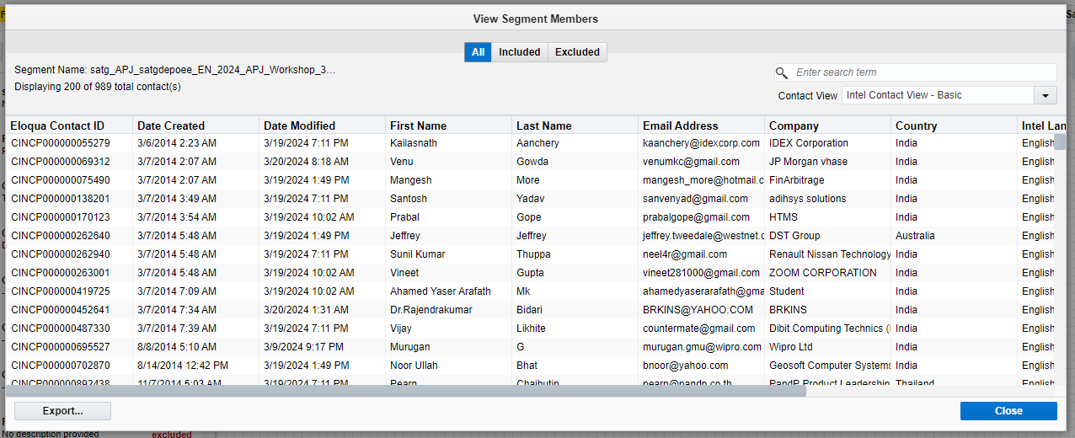

**Seedlist Segment**

**2. Screenshot of schedule time in campaign**

**TY Email**

**Sorry Email**

**3. Screenshot of the Email**

**TY Email**

**Sorry Email**

**4. Screenshot of Email Preview (for 5 random contacts) – if applicable**

**NA**

**5. Screenshot of the Campaign (Before schedule)­­**

**6. Screenshot of the Net New Shared List for Nurture (After Deleting Contacts) – if applicable**

**NA**

**7. Screenshot of the Campaign (After schedule)­­**

